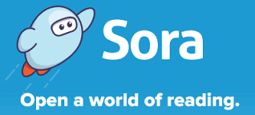
Introducing our new E book and audio book Library!
With Sora, students and staff can access a large collection of ebooks and audiobooks for independent, recreational, or teacher-assigned reading. Books are age appropriate. Students can read or listen to these books using a Chromebook, desktop computer, or personal mobile device.
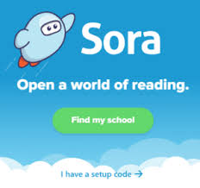
To Download and set up App
- Download the app: Sora, by Overdrive
- Click on Find my school
- ACEN Member collection is our school
If you cant find it hit My school isnt
listed and type in ACEN.
- Select your school- ACEN Member Collection
- Click on Sign in using ACEN Member Collection, which is your school computer user name and password.
To use on the web
Go to https://soraapp.com/welcome and follow the same instructions above.
You are ready to look for your first book!!!!!
- You can click on the magnifying glass in the top left corner to type in a title or author.
- Or you can click on the collections tab and look through the different types of books on offer.
- You can borrow up to 3 books at a time. You can even place holds on books that are checked out.

Enjoy our new ELibrary Mrs Michelle Philpott / Teacher Librarian
michelle.philpott@mn.catholic.edu.au

