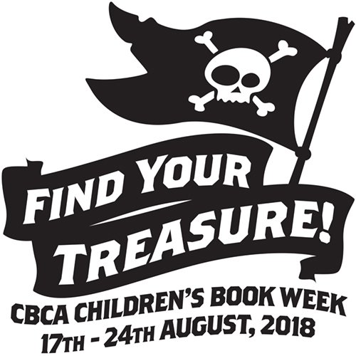
Book Week 2018!!!
FIND YOUR TREASURE
is not too far away!!
As a special celebration for the love of reading at St Paul’s we have organised a visiting performance during Book Week that is an educational musical for all classes K-6. Please fill in the note and return to school with correct money.
Dear Parent/Guardian,
Perform! Educational Musicals, will be presenting a performance of TREASURE HUNT to celebrate 2018 Book Week in school for:

WHO: Grades K-6 EVERYONE!!!
WHEN: FRIDAY, 24th August 2018
WHERE: Church hall
COST: $7 per student

TREASURE HUNT features a selection of the 2018 Children’s Book Council Shortlisted books, providing a gateway into accessing the best in Australian Children’s literature while exploring the themes of inclusiveness and acceptance of others.

Please provide us with your approval by ticking the box below and returning this form and money by Friday 17th August, 2018
Thank you
Mrs Philpott
Teacher Librarian
……………………………………………………………………………………………………………………….
Yes, I wish for my child/children (family name)________________________________
to attend TREASURE HUNT
Child’s name___________________ Class __________
Child’s name___________________ Class __________
Child’s name___________________ Class __________
Child’s name___________________ Class __________

I have included full payment of __________________

Signed: ____________________ Parent Name: __________________

