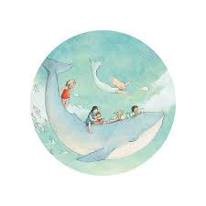
BOOK WEEK: Escape to Everywhere
BOOK WEEK August 21st-24th.
WIN SOME BOOKS FROM OUR FAIR!!
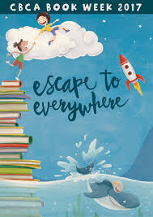
We will be celebrating BOOK WEEK this year in St Paul’s style with lots of exciting and different activities to encourage our students to read more and promote their love of books. Below find numerous competitions to involve all our students at St Paul’s!


Book Week Competitions
DUE in by Wk6 TUES 22nd Aug!!!
K-2 Colouring in competition. Pick up your copy from the Library!!! Winning entry will win a free book from the Book Fair

K-6 Design a Bookmark!- Students may use any form of craft media or materials, like drawing, decoupage, scrapbooking, painting, sewing etc - to create a bookmark based on the theme Escape to Everywhere. Please write your name and class somewhere on the back of your bookmark. Winning entry will win a free book of their choice from the Book Fair.

K-6 Create your own Time Travel Machine:- Use any materials of your choice; paper, lego, playdoh, recycled materials, wood etc for some ideas. Winning entry will win a free book of their choice from the Book Fair.

3-6 Complete 1000 Dot to dots Have a go at trying to complete the dot to dot with over 1000 numbers. Winning entry will win a free book of their choice from our Book Fair!

K-6 Film your own magical ESCAPE story. Sing, recite, act out or even mime to a song. As long as it relates to the theme ESCAPE. Submit film on a disc, USB or email to michelle.philpott@mn.catholic.edu.au Winning entry will win a free book of their choice from our Book Fair!

MORE COMPETITIONS ON THE BACK!
K-6 Make a Book in a Box Select your favourite Book Setting or world from a book and create a diorama. Think outside the box! Book in a jar, in a hat, in a suitcase…Winning entry will win a free book of their choice from our Book Fair!


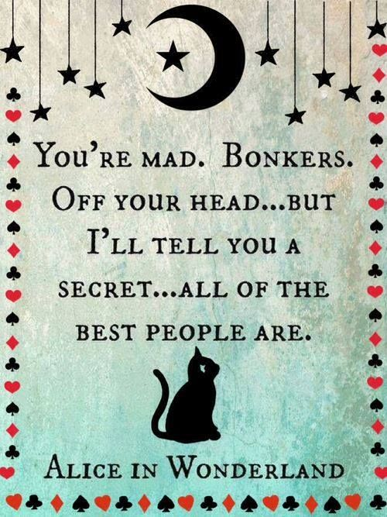
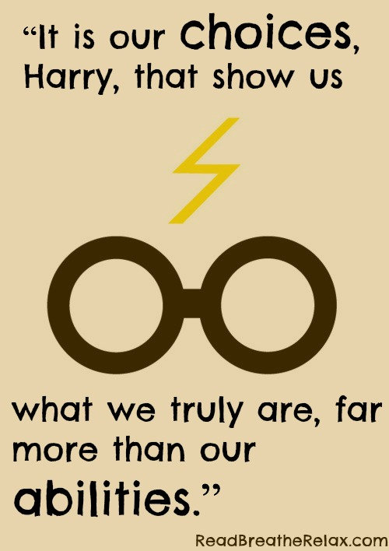
K-6 Book Quote Poster Competition: Take your favourite quote from a book and turn it into a poster. More examples in the Library. Winning entry will win a free book of their choice from our Book Fair! Submit pic on paper or USB or email to michelle.philpott@mn.catholic.edu.au Winning entry will win a free book of their choice from our Book Fair!
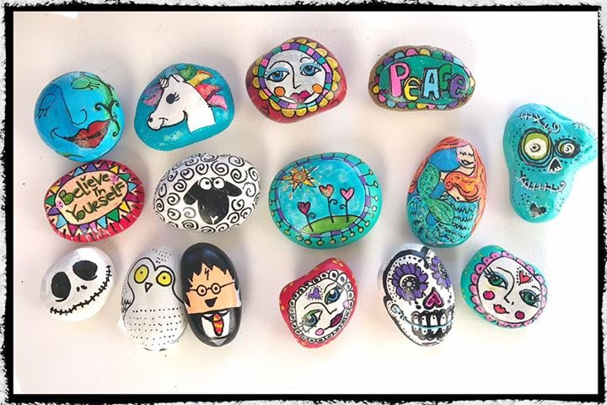
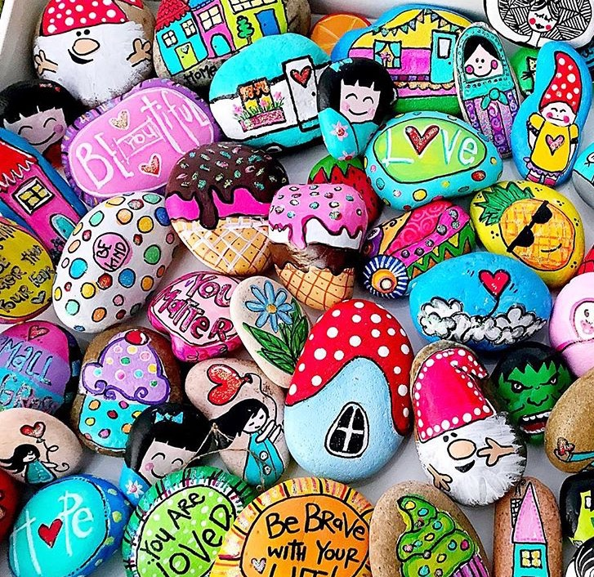

K-6 Create a bunch of Story Rocks. Select your favourite story and create the characters, places, main ideas onto rocks…Winning entry will win a free book of their choice from our Book Fair! (Why not use your rocks to film a movie of your book and enter the film competition as well!!)

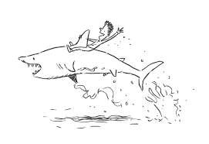
K-6 Write a short story using the sizzling start… ‘I just don’t know how I was ever going to escape. Winning entry will win a free book of their choice from our Book Fair!
These competitions are completely voluntary and can be completed at home. Try 1, try them all!!!! All entries must be submitted by Tues 22nd August!

